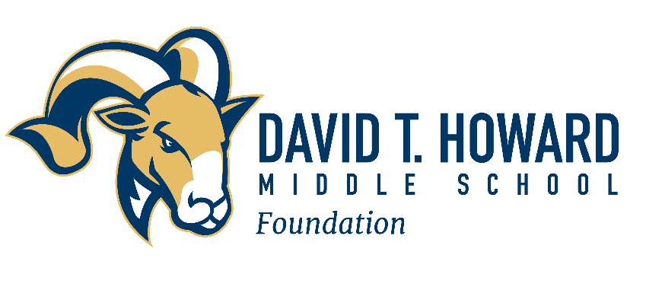

September 19, 2022

Dear David T. Howard Family,

After these last few years that have challenged us in ways we never imagined, we remain grateful for the student, faculty and parent community at David T. Howard Middle School.

Despite the twists and turns of recent years, your steadfast commitment to lifting the school and its students through your generous gifts make a difference in what we can achieve together. Your support through the David T. Howard Middle School Foundation helps ensure that our students and teachers have the resources needed to thrive academically in a learning environment that is innovative and complete with the resources all students and teachers need to succeed.

As we move forward this school year, we hope you will make a gift to the Foundation to continue these efforts. We want to ensure that our teachers have the opportunity for professional learning as well as the equipment and curriculum resources needed to nurture all students academically. Further, with a new STEAM (Science, Technology, Engineering, Arts and Math) signature program for the cluster, including David T. Howard Middle School, we want to be prepared to make strategic investments that will enable excellence in these areas.

The David T. Howard Foundation helps fill the funding gaps for long-term needs not covered in the Atlanta Public Schools budget. The Foundation makes investments based on the insights and recommendations of the teachers and school leadership, with a focus on technology, curriculum resources, professional development for teachers and building enhancements.

Your donation of any amount makes a real and lasting impact for every student at David T. Howard, and your donations help ensure our teachers have the resources needed to excel in their roles. Donors of $250 or more will receive a yard sign to show your support of our school, students and teachers. All donors will receive a Foundation magnet.

Thanks to the parent community’s support in the 2021-22 school year, the Foundation was able to make significant investments in curriculum resources, professional learning, new tables and more. For full details, please see 2021-22 DTHF Stewardship Report for investments made last year. Gifts may be made online at https://www.atlantapublicschools.us/domain/15257, or by mail at the address below.

Thank you for your thoughtful consideration of our request, and please know that gifts of any size make a difference. We are grateful for all that you do to support David T. Howard Middle School.

Sincerely,

David T. Howard Middle School Foundation Board

Jennifer Warner, President
Lynley Teras, Secretary
Carisa Quinn, Treasurer
Monica Jones
Jordan Krugman
Fontaine Lee
Sarah McLean

Donations by check can be mailed to: David T. Howard Middle School Foundation, P.O. Box 8722, Atlanta, GA 31106.
The Foundation is a 501(c)(3) charitable organization (Tax ID#58-2323822) and donations are tax deductible to the fullest extent allowable by law.

